Logan Gillingham Java QAP 1

Problem #1

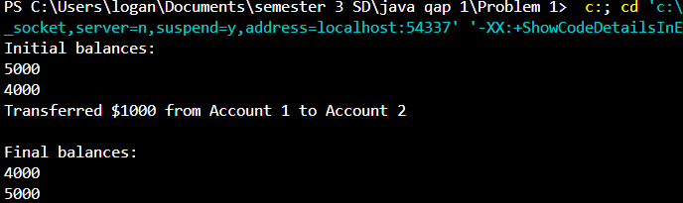

Problem #2



Problem #3

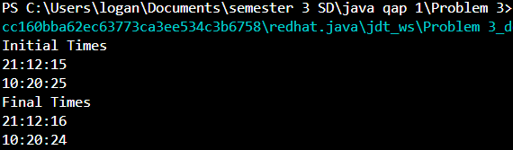

Feedback Questions:

* **Time spent:** Approximately 2-3 hours.
* **Online resources:** I used our lectures, Stack Overflow, and programming forums.
* **Assistance from friends:** No
* **Questions to instructors:** No
* **Difficulty rating:** The questions varied in difficulty. Some were straightforward, while others required more problem-solving and algorithmic thinking. I believe I have a good understanding of the concepts and techniques used in these problems and should be able to apply them to similar tasks in the future.